**Software Requirements and Design Document**

**For**

**Group 11**

Version 1.0

**Authors**:

Juan Dangon

John Torres

Wilfredo Huertas

Mark Mori

# 

# **1.** **Overview (5 points)**

*Give a general overview of the system in 1-2 paragraphs (similar to the one in the project proposal).*

The project is a social media app that is somewhat of a blend of Instagram profiles and pinterest, where people can post events to their profile. Users can create their own profile and post local events they have created that are otherwise hard to find/advertise. If a user wants to find events, they can make their own profiles and search through events that have been posted in their area in a feed. You can also get a better idea of which events are more popular with a like feature.

# **2.** **Functional Requirements (10 points)**

*List the* ***functional requirements*** *in sentences identified by numbers and for each requirement state if it is of high, medium, or low priority. Each functional requirement is something that the system shall do. Include all the details required such that there can be no misinterpretations of the requirements when read. Be very specific about what the system needs to do (not how, just what). You may provide a brief design rationale for any requirement which you feel requires explanation for how and/or why the requirement was derived.*

1. *Full front-end functionality, where all pages that users will access have the inputs necessary for*

*The backend to take in-High*

1. *User authentication- building out user authentication for post ownership and liking posts-medium*
2. *Making a better looking experience, updated styling on all display pages-low*

# **3.** **Non-functional Requirements (10 points)**

*List the* ***non-functional requirements*** *of the system (any requirement referring to a property of the system, such as security, safety, software quality, performance, reliability, etc.) You may provide a brief rationale for any requirement which you feel requires explanation as to how and/or why the requirement was derived.*

1. *The app must run fast enough to switch pages without noticeable delay.*
2. *The app must protect user’s login information privacy when registering and using app features.*
3. *All displays of user information must be consistent across the entire application*

# **4.** **Use Case Diagram (10 points)**

*This section presents the* ***use case diagram*** *and the* ***textual descriptions*** *of the use cases for the system under development. The use case diagram should contain all the use cases and relationships between them needed to describe the functionality to be developed. If you discover new use cases between two increments, update the diagram for your future increments.*

***Textual descriptions of use cases****: For the first increment, the textual descriptions for the use cases are not required. However, the textual descriptions for all use cases discovered for your system are required for the second and third iterations.*

# **5.** **Class Diagram and/or Sequence Diagrams (15 points)**

*This section presents a high-level overview of the anticipated system architecture using a* ***class******diagram*** *and/or* ***sequence diagrams****.*

*If the main* ***paradigm*** *used in your project is* ***Object Oriented*** *(i.e., you have classes or something that acts similar to classes in your system), then draw the* ***Class Diagram******of the entire system and Sequence Diagrams for the three (3) most important use cases in your system.***

*If the main* ***paradigm*** *in your system is* ***not Object Oriented*** *(i.e., you* ***do not*** *have classes**or anything similar to classes in your system) then only draw* ***Sequence Diagrams****,* ***but for all the use cases of your system.*** *In this case, we will use a modified version of Sequence Diagrams, where instead of objects, the lifelines will represent the functions in the system involved in the action sequence.*

***Class Diagrams*** *show the* ***fundamental objects/classes*** *that must be modeled with the system to satisfy its requirements and* ***the relationships*** *between them. Each class rectangle on the diagram* ***must also include the attributes and the methods of the class*** *(they can be refined between increments). All the* ***relationships between classes and their multiplicity*** *must be shown on the class diagram.*

*A* ***Sequence Diagram*** *simply depicts* ***interaction******between objects*** *(or* ***functions -*** *in our case - for non-OOP systems) in a sequential order, i.e. the order in which these interactions take place. Sequence diagrams describe how and in what order the objects in a system function.*

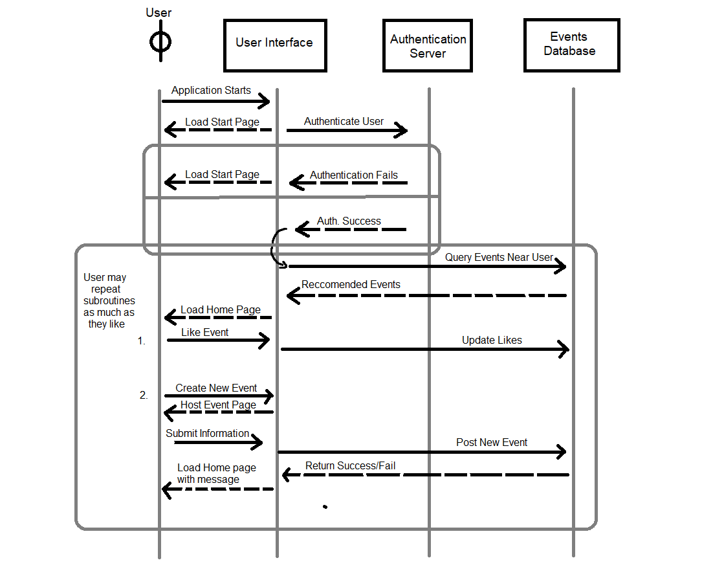

# **6.** **Operating Environment (5 points)**

*Describe the environment in which the software will operate, including the hardware platform, operating system and versions, and any other software components or applications with which it must peacefully coexist.*

Our project will be a multiplatform mobile app that can run on iOS 15 and Android.

# **7.** **Assumptions and Dependencies (5 points)**

*List any assumed factors (as opposed to known facts) that could affect the requirements stated in this document. These could include third-party or commercial components that you plan to use, issues around the development or operating environment, or constraints. The project could be affected if these assumptions are incorrect, are not shared, or change. Also identify any dependencies the project has on external factors, such as software components that you intend to reuse from another project.*

We are using dependencies such as React Native and Navigation and would have to rely on the current version we have installed for all code updates.